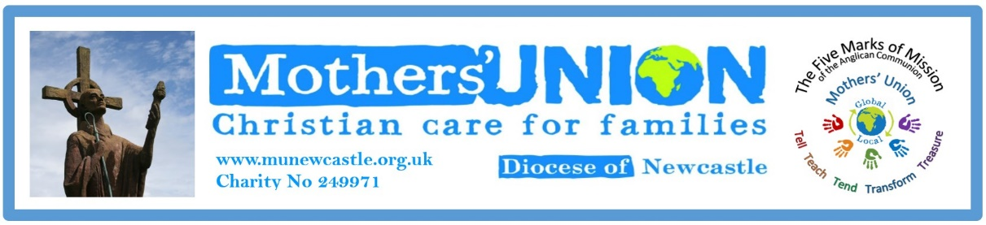
Website Report for Trustees September 2023
- The website has now been updated and went live with the latest updates in August 2023. Many thanks to Rev Anne Marr for her support and excellent input in achieving this. If you haven’t checked it out, then please do so www.munewcastle.org.uk, On the website you can see what has been happening around the diocese, get ideas and prayer resources for use at your branch meetings as well checking on times and dates for items in the future.
- We continue to have problems with some branches sending items for both the website and Facebook. Although we may not use Facebook or websites personally, both these forms of media are followed by people all over the world and if we are to move into the 21st century then we DO need to share our ideas and activities- as the Archbishop of Canterbury once said. ‘Mothers’ Union is the churches best kept secret!!’ So please try and nominate someone from your branch to take on this role. As if you were at the Annual Gathering you will have heard the Mothers’ Union IS FAITH IN ACTION.
- We have now been setting up emails for officers in Newcastle MU to safeguard personal emails as well as introduce some conformity to the organisation. The following are up and running so please add them to your contacts and use them for all MU business. The names are self explanatory!
- president@munewcastle.org.uk Margy Tasker- Brown
- chaplain@munewcastle.org.uk Rev Anne Marr
- vpnorthumberland@munewcastle.org.uk Anne Blight
- vplindisfarne@munewcastle.org,uk Anne Cairns
- actionandoutreach@munewcastle.org.uk Diana Macnaughton
- barbara@munewcastle.org.uk Barbara Packer
- website@munewcastle.org.uk Elizabeth Dean

