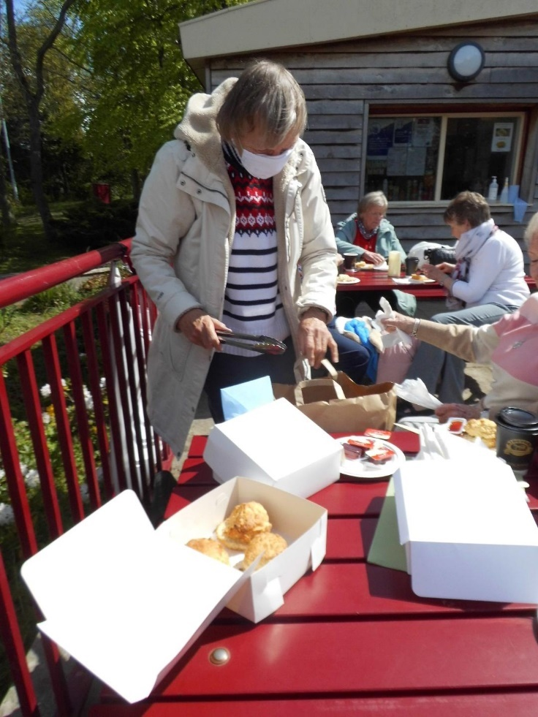
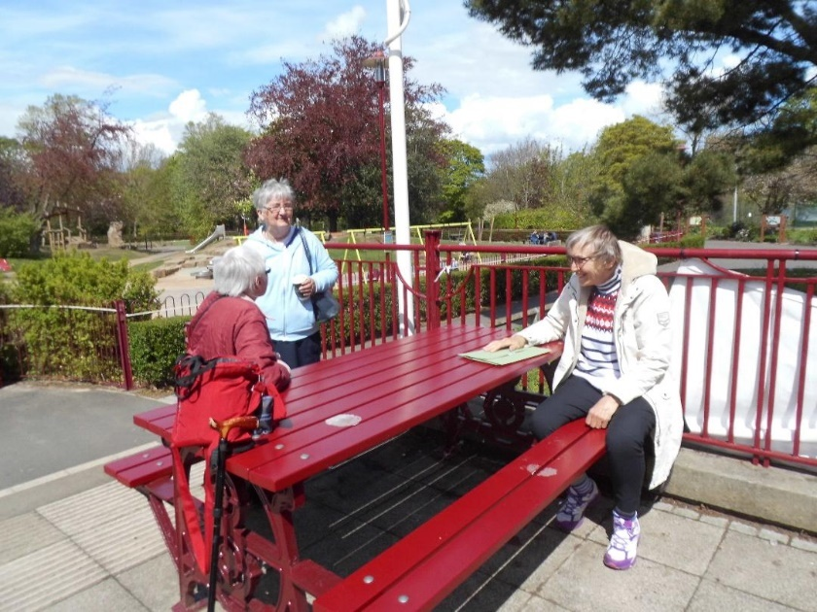
On May 18th, members of St Luke’s branch of Mothers Union Wallsend met up in Richardson Dees Park to raise funds for AFIA. Whilst being socially distanced, nine members were able to meet up in the park on the day after lockdown restrictions were eased and enjoy tea and scones. They could chat to one another in the warm sunshine. Seven members were unable to attend.

