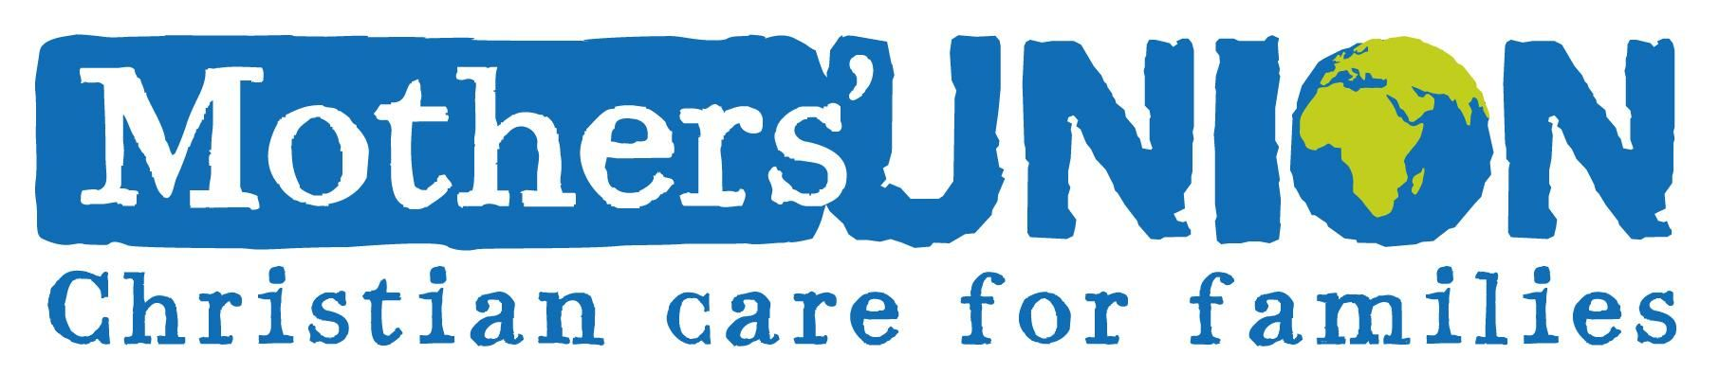
From: Julian Brown – Finance Trustee and Acting Treasurer

Membership and Finance Matters
As at 3rd September, 2024

Membership
During the past year, we have lost 4 branch groupings:-

Killingworth
Belford
Norham
And most recently, I have been told about Stannington.

Norham, with a new vicar about to be present, have asked that there’s might be treated as a “Leave of absence”, although they are not confident of resuming.

As of the time of writing, our national database, which for all its faults is the one we have to use, shows a membership of 652, of which 30 are listed as Indoor. The entiries held are only as good as the information I receive, so it’s up to the branches to keep me informed of new members, and those who have died, resigned, moved away etc. The only way I can currently keep abreast is when I get the annual returns at the start of February each year which is not ideal for planning purposes.

I sit on the oversight committee for the planning and implementation of our new and long awaited CRM (Customer Relations Management) database replacement system. We meet quarterly to get a report on progress. Our next meeting is in October, and progress may be slow, but it is exacting. Clare Thomas from St Eds, and I are the only members away from MSH, and have had a considerable level of input, but are limited to a point by cost constraints. ETA of the system is currently February 2025, with testing starting either just before or just after the Christmas break. The data will be transferred on acceptance, probably mid February, and the old system will be switched off on the same day! Each Diocesan grouping will initially only have one login, due to again to cost constraints.

COI meetings are similarly held quarterly, with representatives from all the Dioceses invited. I am afraid to say these have become rather tedious as the questions asked and points raised seem in the main to be repetitions of the contents of earlier meetings. It does provide a means of getting to know people in a similar boat, and fostered some friendships along the way.

Direct Debits

Barbara Packer continues to do sterling work in organising and chasing up membership Tributes paid by DD. Currently about 50% pay their subs that way. There are drawbacks to the administration of the scheme as MSH pay the Diocese back in full for the payments received, at which point, I have then to repay the fullness of the National Capitation back to them!!! This I have to do together with remittances of MSH charity contributions from the branches and individuals.

Gift Aid

Since Lesley’s retirement, and we must extend our thanks to her for her hard work over the years, we have yet to find a person to take over the administration of this task. I certainly do not have the time to take on this as well. After a false start earlier this year, we are still looking for someone to take this over. We have applied to a body who helps in finding volunteers, but have yet to find anyone coming forward.

Treasurer

I took over the job as interim treasurer on Dorothy’s passing in May 2022. It’s a job I have been professionally trained to do, but it was only understood to be on an interim basis. All the record keeping is now set up on Intuit Quickbooks, a cloud based system accessed from my laptop, which does all the hard work, for which we pay a monthly subscription. If anyone feels so inclined, I would be delighted to pass the job on. My spare time is limited, and it would be one less job for me to do. Bankings involve a trip to the Post Office, if you’re not close to a branch of Barclays, whilst payments are made from the comfort of your desk using Internet banking, and the only other requirement is using email.
Alternatively, if someone would be prepared to take on the Database role, whilst I retain the Treasurer role, I would be happy to consider that. With the new system, it should be a breeze.

Julian Brown
3rd September, 2024.

