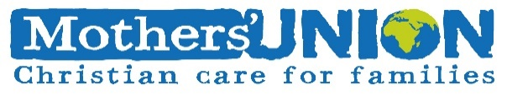

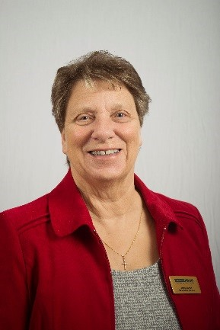**Reflection July 2024**

My dear friends, greetings in the name of the Lord Jesus Christ. I hope you are keeping well and have plenty of visitors, both family and friends, who will keep you cheerful, make you feel cared for and even enable you to get out to see the world around you. July is a busy family month for me, with birthdays, wedding anniversaries and even a graduation this year. My granddaughter graduates on the 15th July and celebrates her 21st birthday on the 22nd so a big year for her. It is also the time for us to celebrate with the members in the DRC [Democratic Republic of Congo] who have been helping women in their community to become literate and numerate, so that they are able to release themselves from poverty by understanding how to read and count. That way when they take their produce to market, they are not robbed because, they understand the value of the things they are selling. In the past two years 2,635 people have been helped thanks to the generosity of those subscribing to the ‘Summer of Hope Campaign’ This year I want to encourage you to help them build on their success in any way you can, by helping to raise more money, so that the programme can be extended and up to 4,800 more people can be helped. It is so important to be able to read, write and understand simple arithmetic. Part of the work that I do with my church is to go into some of my local schools and listen to children read. Some of these children struggle because English is not their first language and with the increasing number of refugees in the UK, I fear this situation will only increase, not only with children but with adults also.

So let us celebrate the success so far of our members in the DRC and help them reach new targets by supporting the ‘Summer of Hope Campaign’ even if that is only by prayer or sponsoring a member to undertake a physical challenge. Maybe your local branch will be holding a bake sale, I can think of nothing nicer than a slice of cake with my cup of coffee, particularly if it also raises much needed money to improve the lives of others. In his earthy ministry our Saviour spent much of his time teaching and healing. In all the Gospels we can read about the feeding of the 5000 who had gathered to hear Jesus teach. We are told that he taught them many things and as the time was getting late the Disciples urged him to send the people away so that they could get something to eat.

But Jesus had more teaching and with the help of just a small amount of food from a young boy and the blessing of the Holy Spirit a miracle happened, and all the people were fed with more food to spare. This was Jesus feeding the people physically, but it also enabled him to speak about faith, faith that was borne out by the fact that because Jesus had faith in his heavenly Father, he was able to use just a small amount of food to fulfil the needs of many. That same faith is ours and if we all pull together and share that faith, we too will be able to perform miracles because our small contribution to a big campaign will enable the MU in many places to benefit and have opportunity to understand things which many of us take for granted. So, I wish you every blessing, praying that you will be able to enjoy the many gifts which God has given and encourage you to share that blessing with those around you.

Love & Prayers

Jenny

**Let us pray!**

Lord God, we hold up to you the communities involved in the Mothers’ Union Literacy Agriculture project in the DRC. We pray for your guidance and wisdom to be upon each person involved in this project. We ask for your protection over them and their families as they navigate through any challenges or obstacles. We pray that, through this project they may gain knowledge and skills that will bring about positive change in their lives. May they experience your abundant blessings in the form of improved literacy, better health, and increased self-sufficiency. Through your guidance and wisdom, may this project grow and flourish. Bringing hope and transformation to the communities it serves. Amen

*MU prayer for Summer of Hope*

Thank you, Lord, for making the land, sun, and seas. Thank you for making the grass, flowers, and trees. Thank you for making animals, large and small. And thank you for making my family and friends, most of all.

*Leslie Harris, Diocese of Lichfield. From Dear Lord*

Father, we ask your blessing on our Summer of Hope Campaign. May we be prayerful and generous in our giving. Walk with all who organise or take part in activities to raise money for this wonderful cause. Bless also the work of the MU, our worldwide President, the Board of Trustees and all who work tirelessly at MSH to ensure the work of this wonderful organisation benefits all who are in need.

In Jesus name Amen