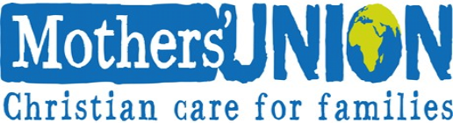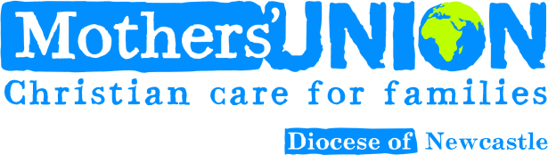

Please fill in the whole form using a pen and send it to
Canon Barbara Packer Devonshire House Alma Place
Whitley Bay NE26 2EQ

Member full name

Joint member name (if applicable)
Instruction to your Bank or Building
Society to pay by Direct Debit

MU Newcastle Membership
Originator’s Service User Identification Number

Collection reference

Home address
Membership type (please tick)

Home postcode MU Branch or Group

Email address Instruction to your Bank or Building Society

Name(s) of Account Holder(s)

Branch Sort Code
Please pay Mothers’ Union Direct Debits from the
account detailed in the Instruction subject to the safeguards assured by the Direct Debit Guarantee. I

understand that the instruction may remain with
Mothers’ Union and, if so, details will be passed electronically to my Bank/Building Society

Branch/Building Society account number
Date
/
(DD/MM/YYYY)
/

Bank or Building Societies may not accept Direct Debit instructions for some types of account
The Direct Debit Guarantee
This Guarantee is offered by all Banks and Building Societies that accept instructions to pay Direct Debits
- If there are any changes in the amount, date or frequency of your Direct Debit, Mothers’ Union will notify you 10 working days in advance of your account being debited or as otherwise agreed. If you request Mothers’ Union to collect a pay-ment, confirmation of the amount and date will be given to you at the time of the request.
- If an error is made in the payment of your Direct Debit, by Mothers’ Union or by your bank or building society you are
entitled to a full and immediate refund of the amount paid from your bank or building society.
- If you receive a refund, you are not entitled to, you must pay it back when Mothers’ Union asks you to.
You can cancel a Direct Debit at any time by simply contacting your bank or building society. Written confirmation may be required.
Please consider completing the Gift Aid declaration too.

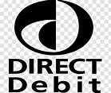

Signature(s)
Telephone number

