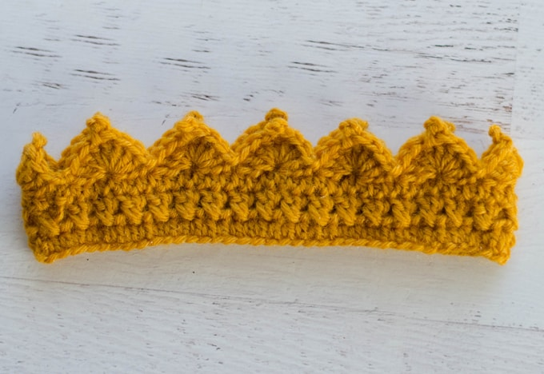
Crochet Crown Pattern

US G6/4.00 mm crochet hook
Lion Brand Wool-Ease in Gold, 3/8 oz (25-30 yards).
Tapestry needle and scissors
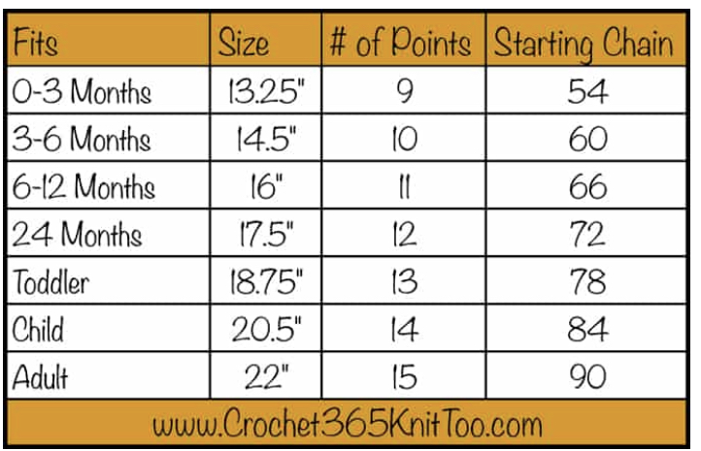
Chain the number of chains indicated for the particular size you want to make. Join with a slip stitch to the first chain, being careful not to twist the chain. If possible, try the chain ring on the person who will be wearing the crown. It will stretch a bit when done. But now is a good time to change sizes if you need to.
Row 1: ch 2 (counts as 1st hdc) Hdc in each chain. Join with slip stitch to the top of the starting chain.
Row 2: This row is a X stitch double crochet round. To start, Chain 3 (counts as 1st dc), dc in the previous hdc (in this case, the last stitch of the previous round, this double crochet should cross over the starting chain 3 (see photo). Going forward again, skip the starting ch and *skip the next st, dc in the next st, dc in the previously skipped stitch, crossing over the stitch just worked*. Repeat * to * around the crown. Join with a sl st to the top of the starting ch 3.
Row3: ch 2 (counts as 1st hdc) Hdc in each st. Join with slip stitch to the top of the starting chain.
Row4: sl st in next st, *skip 2 st, in next stitch, work [4dc, ch 3, sl st in previous dc (forms the picot), 3 dc], skip 2 st, sl st in next st*, repeat * to * around. Join with sl st to starting st. Fasten off and weave in ends.

