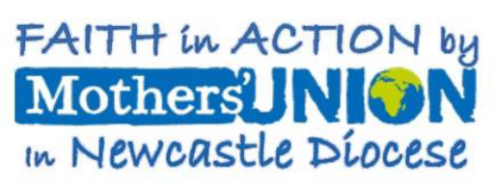

Diocesan Council Meeting
on Friday 9th October at 1.30pm in St John’s Kingston Park.
Refreshments served from 1.00pm.
AGENDA
- President’s welcome.
- Opening worship led by our Chaplain, the Rev’d. Anne Marr.
- RIP’s since last Council.
4 Apologies.
5. . New Members
- Welcome to members attending Council for the first time.
- Minutes of the last meeting held on 27th March 2026 (attached).
- Matters Arising..
- President’s remarks.
10. Reports from COI’s - Communities of Interest.
- Financial & Central services.
- Membership.
- Safeguarding.
d) Communications.
{e) AFIA.
(f) Prisons.
(g} Domestic Abuse.
(h} Modern Slavery.
(i) Faith .
12. Reports
a) Prioject team.
b) Deanery Reports,
c) Diocesan members.
13 Any Other Business - 48 hours notice required.

Speaker: Rev’d Fiona Sample MBE – Founder of The Oswin Project.

Dates 2026
5th November Midday Prayers at Cathedral.
28th November Packing day at Holy Nativity.
30th November Corbridge & Hexham Deanery Advent Service at Hexham Abbey 1pm.
3th December Midday Prayers at Cathedral. 16 Days of Activism.
4th December Gift Bag Day and Coffee Morning at Church House.from 10.30am.
7th December West Deanery Advent Praise at Holy Cross Fenham at 2pm.
9th December Northern Deanery Advent Service at St Michael’s, Alnwick at 10.15am.
14th December Tynemouth Deanery Advent Service at St Peter’s, Monkseaton at 2pm.

Please read and have available the Agenda and attached reports, which will not be
read out at the meeting; but any questions will be answered. Please ensure that
others attending Council also receive the papers.

All members are welcome to join us.

