Beatitudes for Transformation times
These 10 beatitudes can be found in slate roundels in the paved way
around Newcastle Cathedral. Do find them and who they relate to.
You may wish to write your own. Then visit Café 16 for coffee or lunch.
(Or join MU members for Midday Prayer at 12.00 on any 1st Thursday of the month.)

Blessed are the revellers, the story-tellers,
for with them is the delight of re-creation.

Blessed are the creative, the designers, the artists,
for they help us to see the world differently.

Blessed are the office blocks, places of labour and love,
for they ask of us what it is we’re working for.

Blessed are the back alleys,
for they remind us of those tasks and people whose value remains hidden.

Blessed are the lights on our path,
for their guidance and protection gives us courage to take one more step.

Blessed are the places where we stop and rest,
for they restore us to our true selves.

Blessed is the world around – the beauty and the plain –
for through it, we too are blessed.

Blessed are the bustling travellers, tourists, business folk & barristers –
for they remind us to use our time well.

Blessed are the strong and those that nestle in their shade,
for together they make the city a sanctuary.

Blessed is the Amen,
for it marks the ending but creates fresh space for beginnings.

…and two more… Blessed are the gardeners and housekeepers of
our planet for they will safeguard creation.

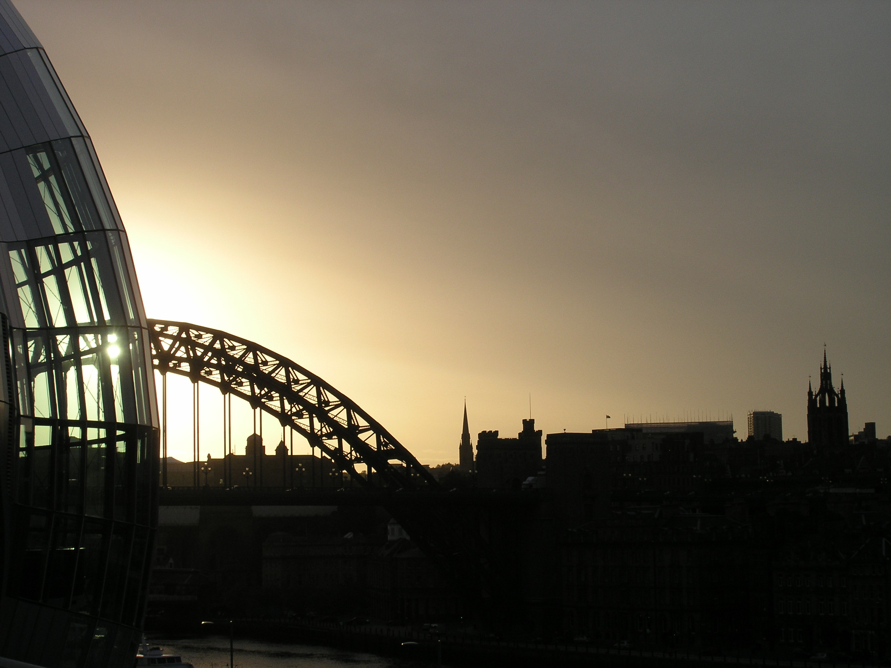
Blessed are mothers and those who nurture children,
for they transform the ways of the world.

Amen

Photo © AEM
Information about the Mothers Union link with Newcastle Diocese and Cathedral can be found on the Cathedral website in the ‘Get Involved’ section –www.newcastlecathedral.org

