

**General Meeting 2017 Information Pack**

**Edinburgh 29th – 30th September**



Contents

Welcome to Scotland! ...............................................................................2

Edinburgh Rewards Passport …………………………………………………………………………………3

Timetable of Events .………………………………………………………………………………………………4

General Meeting ..........................………………………………………………………………………5

General Meeting – Venue & Tickets ………………………………………………………………………6

General Meeting – Lunch & Refreshments.……………………………………………………………8

General Meeting – Travel to EICC ……………………………………………………………………...10

Annual Service – Venues …………………………………………………………………………………….12

Annual Service – Tickets ………………………………………………………………………………………14

Annual Service – Travel ……………………………………………………………………………………….15

Travelling to Edinburgh ……………………………………………………………………………………….16

Accommodation in Edinburgh ……………………………………………….…………………………….18

A Taste of Scotland Dinner ………………………………………………………………………………….19

A Taste of Scotland Dinner – Venue ……………………………………………………………………20

A Taste of Scotland Dinner – Tickets ………………………………………………………………….21

A Taste of Scotland Dinner – Directions .…………………………………………………………….22

# Province of Scotland.jpg

# Welcome to Scotland!

# 

# 

# Dear Fellow Members

# The MU members in Scotland are delighted to be hosting this year’s General Meeting (or as the Scots prefer to call a family get-together, “Gathering”). So on behalf of the members and Provincial Trustees, WELCOME TO THE GATHERING!

# Unlike other General Meetings, this event is hosted by the Province so we have two teams from across the dioceses working together. One team is preparing the church services and the other the marketing and stewarding. It is a great way of strengthening our inter-diocesan links, with the added bonus of creating friendships; so we are all thoroughly enjoying our time together as we prepare to ensure you have a the best possible time imaginable!

# We hope you will enjoy Evensong at our St Michael’s Day Annual Services being held in St Mary’s Scottish Episcopal Cathedral, Palmerston Place and St John’s Episcopal Church, in the West End (corner of Princess Street).

# 

# We also hope that you will enjoy our venue for the General Meeting which is new to us and has been chosen for its inclusiveness. With its fabulous food, secure luggage storage, spacious area for perusing sales tables, display area and quiet/prayer room, there will be no need to waste time going out at lunchtime looking for a café. In addition we are planning to make your visit all the more memorable by eliminating the queuing at the sales tables. Shortly you will receive an advance sales leaflet so all you need to do is “Claim and Collect” – providing you with more time to meet old friends and make new ones. What could be better?

# Whilst you are here we hope you will be able to enjoy some of the unique sights and experiences Scotland has to offer and in connection with that, the Tourist Board have been working very closely with both MSH staff and MU Scotland to ensure that your visit is as smooth running and pleasant as possible. Their input has been invaluable.

# Together we hope to provide an unforgettable and thoroughly enjoyable time with us here in Edinburgh. Looking forward to seeing you!

# Jean McPherson-Richardson, PP Scotland

# Helen Godfrey, DP Edinburgh Diocese

# *On behalf of the Trustees Board and Members of the Mothers’ Union in the Province of Scotland*

# 

# Your Passport to the City of Edinburgh

**Edinburgh Rewards Passport**

We want to enhance the General Meeting experience for our members visiting Edinburgh so the handy pocket size Edinburgh Rewards Passport we will be giving every member attending not only a city map, handy tips, highlights city events but also gives access to exclusive offers.

The Edinburgh Rewards Passport provides a wonderful choice of places to wine, dine, shop or guide members to some of the best visitor attractions, giving specially negotiated ‘rewards’, a discount or an added value offer.

There are over 100 participating businesses looking forward to welcoming members, with offers ranging from 25% off their food and bar bill, to a complimentary cocktail on arrival, and many more. The Passport allows delegates to receive any ‘Edinburgh Reward’ as advertised and is used in conjunction with the website [www.edinburghrewards.com](http://www.edinburghrewards.com) and the free downloadable YogoBogo app, both listing all the up to date fantastic offers!

*Thank you to Convention Edinburgh who have worked with us to supply members with these great offers.*

**Timetable of Events**

**Wednesday 19th April 2017**

**9.00am** Tickets released for General Meeting

Tickets released Taste of Scotland and Ceilidh band evening

**Monday 1st May to 30th May 2017**

Ticket application for services open

**Friday 29th September 2017**

**5.30pm** Service of celebration

**7.30pm “**A taste of Scotland Evening” with Ceilidh Band at

The Roxburghe Hotel

**Saturday 30th September 2017**

**9.15am** Doors Open

**10.30am – 3.30pm** General Meeting at the Edinburgh International Conference Centre

**General Meeting**

As **Faith in Action** is the theme for the year this event will celebrate all that is Mothers’ Union nationally and worldwide.

Our programme, to be released in due course, will feature a keynote on ‘Peace & Reconcilliation’ which we are pleased to reveal will be led by the Archbishop of Canterbury’s top advisor – Canon Sarah Snyder (<https://goo.gl/9vimLZ> )

*Did you attend the 140th Anniversary General Meeting? Did you make a pledge on the day and would be happy to tell us how it changed you, your community or wider? If so we would love to hear more! Email us at* [*communications@mothersunion.org*](mailto:communications@mothersunion.org)

**General Meeting Venue: The EICC**

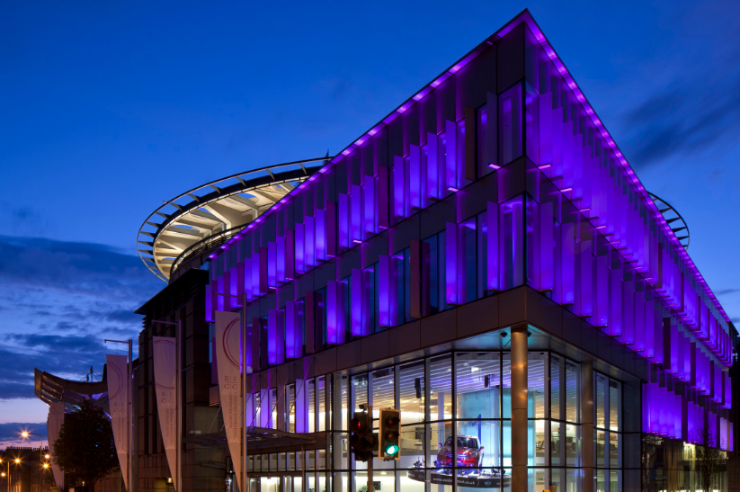

Situated at the heart of Scotland's beautiful capital city, the Edinburgh International Conference Centre (EICC) is one of the world's most outstanding venues for conferences and events. The purpose-built centre offers the very best facilities and technology; and their experienced team are looking forward to welcoming our members.

This venue is really special, accommodating all of our members needs - we are excited to be holding our General Meeting in this prestigious venue!

Tickets will be available to purchase online on **Wednesday 19th April 2017**. There are 2000 seats available, which means plenty of space for everyone.

Tickets will be priced at £15.00 per person.

You can book you ticket through the EICC by visiting the following website:

<http://www.eicc.co.uk/whats-on/mothers-union-general-meeting/>

**All tickets will be sent via email** - please make sure you print them off and have them with you so they can be scanned as you arrive.

**Booking Fees**

£1.50 per booking of up to 8 tickets.

£5.00 per booking of up to 30 tickets.

* Following feedback from 2016, the box office process has been a priority and this year significant savings have been arranged for group bookings.

**Special Requirements**

There will be specific areas in the venue that are used for delegates with special requirements / access needs. If you need accessible seating please call **0131 519 4156**. Tickets will be sold on this telephone line from April 18th for any customers requiring accessible seating, arranging companion tickets and other similar booking assistance.

For those with hearing difficulties, there will be an induction hearing loop in the venue.

If you encounter any problems then please call The EICC on 0131 519 4156

**There will be complimentary Wi-Fi for all those attending.**

**Cloakroom & Left Luggage Facility**

There is a large Left Luggage and Cloakroom facility at the EICC where you will be able to leave any coats, suitcases and bags. **This facility will be free of charge.**

# Prayer Room

We are delighted that this year we will have a prayer and faith room which will be open throughout the duration of the General Meeting. This space will be a place for quiet and reflection, with volunteers who will pray with you should you wish.

**Lunch & Refreshments**

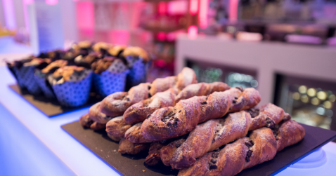

Tea, coffee, drinks and snacks will be available to purchase at multiple stations throughout the General Meeting venue from the moment the doors open (9.00am) to when they close (4.30pm).

We are very excited that this year we will have a FOOD HALL where delegates can sit together (whether you are having a packed lunch or plan on buying a lunch) in one lovely big area. There will also be other areas around the venue where you can sit – we are not lacking in space this year!

You are welcome to bring a packed lunch HOWEVER you may well be enticed with the wonderful selection of food that will be available from the EICC.

Dietary requirements will be catered for.

*“The EICC enjoys a long-standing and successful partnership with Leith’s who have operated as our food and hospitality team since we opened in 1995. Central to Leith’s style is Prue Leith’s conviction that food should be simple but excellent. Leith’s at the EICC are still true to the original cultural and culinary values set out by Prue herself, which are fundamental to the company. Leith’s are uncompromising in their use of fresh, natural ingredients and their talented and passionate chefs source the best seasonal produce available.”*

   



**Freshly made Sandwiches**

Tuna and Herb Mayonnaise Bloomer

Ham and Mustard Mayonnaise on Onion Seeded Bread

Applewood Cheddar and Chutney Focaccia (v)

£3.95 each

**Delicious Salads & Hot Dishes**

Sun blushed Tomato and Feta Cous Cous Salad ~ £3.25 each

Tempting Hot Dishes from £7.50 each

**Tasty Soup**

Homemade Leek and Potato served with Today Bread

£3.50 each

**Drink and Snack Bar Menu**

**Cappuccino £2.75**

**Latte £2.75**

**Americano £2.60**

**Espresso £2.00**

**Mocha £2.85**

**Flat White £2.60**

**Hot Chocolate £2.75**

**Tea £2.00**

**Mineral Water (500ml) & Cans of Soft Drink (330ml) £1.40**

**Orange Juice (Glass) £1.40**

**Pastries & Muffins £2.40**

**Almond Biscotti £1.85**

**Shortbread Doubles £1.50**

**Organic Crumbles and Shortbread £2.20**

**Crisps £1.20**

**Chocolate Bar (Various) £1.00**

**Green & Blacks Organic Chocolate £1.40**

**Fine English Peppermint / Lemon Tea £1.50**

**(All Coffee is available in Decaffeinated)**

**(Please note some of the above is subject to availability)**

# Travelling to EICC

Edinburgh International Conference Centre (EICC)

The Exchange

Edinburgh

EH3 8EE

With its central location and excellent air links and rail and road network, getting to Edinburgh and the EICC is relatively simple!

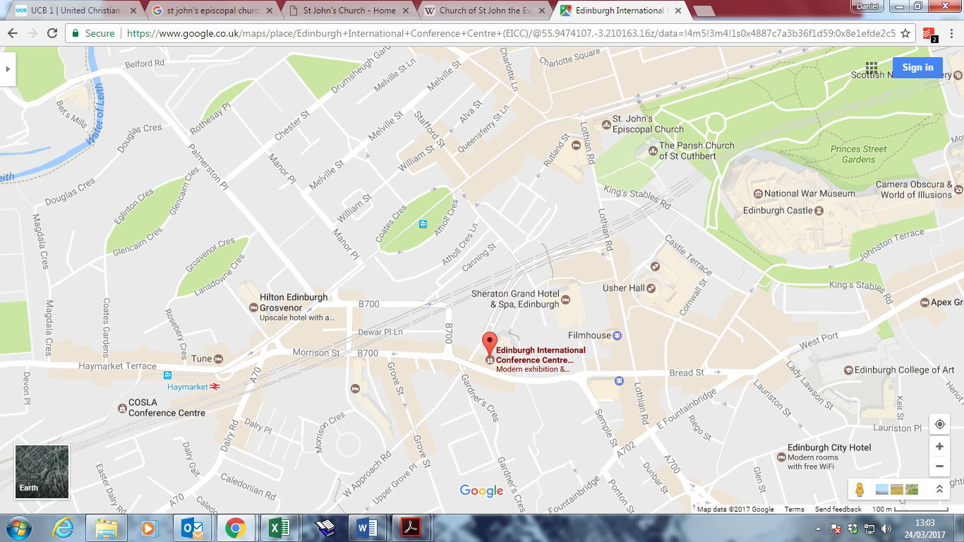

The EICC is right in the centre of Edinburgh. The main entrance is on Morrison Street. For directions from your home or hotel visit [maps.google.com](https://goo.gl/maps/DcaviRwtWru) and input **EH3 8EE** as the destination postcode.

Delegates are advised to disembark at Haymarket Railway Station and to follow signs for EICC on foot (5 minute walk).

**Parking near the EICC**

There are many car parks in close walking distance to the EICC. Please access the following links for further details:

[Sheraton Hotel Car Park](http://www.sheratonedinburgh.co.uk/en/car-park) is 150 metres from the EICC, with limited accessible parking spaces

Cost: £4 for first hour

+£2 for every additional hour

£20 for 8-24 hours

[Semple Street Car Park](http://www.britannia-parking.co.uk/regions/detail.php?park=151) (Brittania Parking) is 300 metres from the EICC

Cost (Saturday): £2 for first four hours

£5 for up to eight hours

£12 for 8-24 hours

[National Car Parks (NCP)](https://www.ncp.co.uk/find-a-car-park/car-parks/edinburgh-castle-terrace/) 650 metres from the EICC – cheaper to book in advance on NCP website www.ncp.co.uk

Cost: £5 for first hour

£9 up to two hours

£12 up to three hours

£15 up to four hours

£18 up to five hours

£22 up to six hours

£25 up to seven hours

£28 for 7-24 hours

**Annual Service**

**St Mary’s Cathedral, Edinburgh**

[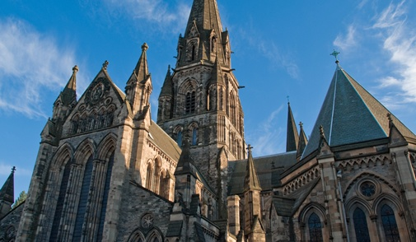](http://www.google.co.uk/url?sa=i&rct=j&q=&esrc=s&source=images&cd=&cad=rja&uact=8&ved=0ahUKEwiFy6mdr8vRAhXGvBQKHdxUC2IQjRwIBw&url=http://www.cathedral.net/&psig=AFQjCNFw_9JWSzw9ztC1Vs7l8nx4glK5Bg&ust=1484817728956939)

**St Mary's Cathedral** (or the Cathedral Church of Saint Mary the Virgin) is a cathedral of the Scottish Episcopal Church in Edinburgh, it will hold up to 1,000 for the Annual Service on 29th September. It was built in the late 19th century in the West End of Edinburgh's New Town. The cathedral is the see of the Bishop of Edinburgh, one of seven bishops within the Episcopal Church, which is part of the Anglican Communion.

The cathedral was designed by Sir George Gilbert Scott and the foundation stone was laid on 21 May 1874 by the Duke of Buccleuch and Queensberry. The twin spires at the west end, known as "Barbara" and "Mary" after the Walker sisters, were not begun until 1913 and completed in 1917. The architect for these was Charles Marriott Oldrid Scott, Sir George's grandson.

The Cathedral is famous for its three spires which can be seen from most places in Edinburgh. The three spires and open doors are signs of:

* A place of stillness in the heart of Scotland’s capital
* A place where God’s praises are sung daily by the Cathedral choir
* A place where a large congregation meets each Sunday, stretches out hands to receive the Bread of Life, or shares in the solemnity of Choral Evensong.
* A place which lets its buildings and site be used for the wider community: a nursery; a GPs surgery; outreach for those seeking mental health services; gardens for all to share.

For more information about the cathedral and its facilities please visit their website:

<http://www.cathedral.net/>

**St John’s Scottish Epicopal Church, Edinburgh**

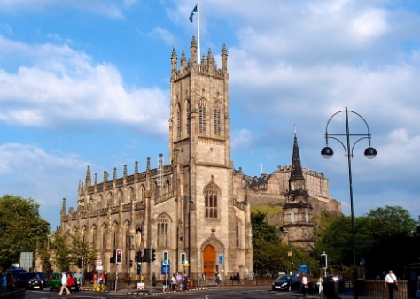

Should we exceed the maximum capacity of St Mary’s Cathedral this church will serve as our second venue. [St John's Scottish Episcopal Church](http://www.stjohns-edinburgh.org.uk/), on the corner of Princes Street and Lothian Road, will hold its service at the same time so that we can accommodate all members who wish to worship together.

St John's is a thriving Scottish Episcopal church at the heart of Scotland’s beautiful capital city.

It was designed by the architect William Burn in 1815, at the remarkable age of 25; construction began in 1816 and was dedicated as St John’s Chapel on Maundy Thursday 1818. The plaster ceiling vault is derived from that found in the Henry VII Chapel in Westminster Abbey.



**MOTHERS’ UNION GENERAL MEETING 2017**

# APPLICATION FOR TICKETS FOR ANNUAL SERVICE

**FRIDAY 29 SEPT 2017 – FESTAL EVENSONG SERVICE AT 5.30PM**

On Friday evening, 29th September, there will be services held at

St Mary’s Cathedral, Palmerston Place, and likely at St Johns Church, Princes St.

Please complete this application form for Service Tickets and return from **1st - 30th MAY**

Tickets will be allocated and issued from **June/July** on a first-come basis.

Please enclose a C5 stamped-addressed envelope with your application.

Please complete the following:

I wish to apply for ……….. tickets (insert number of tickets required)

My contact information is:

Diocese of …………………………………………………………….

Title ……….…….. First Name …………………….………… Surname ……………………………………

Address …………………………………………………………………………………………………………………….

…………………………………………………………………………………………………………………………………..

Postcode: …………………………………….… Telephone: ……….……………………………………………

Email …………………………………………………………………………………………………………………………

Any special requirements (e.g. mobility)

……………………………………………………………………………………………………………………………………

……………………………………………………………………………………………………………………………………

Send your completed application form by 30th May 2017 to Mrs Helen Godfrey at the address below. Don’t forget to include a C5 stamped-addressed envelope.

**Mrs Helen Godfrey, 110 Liberton Brae, Edinburgh EH16 6LA**

**Enquiries: Telephone: 0131 531 0247; helengodfrey43@outlook.com**

Group bookings: Please return any tickets that are not needed

to Mrs Godfrey no later than 7th September.

# Travelling to St Mary’s Cathedral

St Mary’s Cathedral  
Palmerston Place  
Edinburgh  
EH12 5AW

The three spires of St Mary’s dominate the skyline of the West End of Edinburgh and are clearly visible as you look west along Princes Street. The Cathedral’s main entrance is on Palmerston Place, some ten minutes’ walk from the West End of Princes Street, and five minutes from Haymarket Station.

Numerous buses on the way to Haymarket stop near the bottom of Palmerston Place, on Haymarket Terrace, a few hundred yards from the Cathedral.

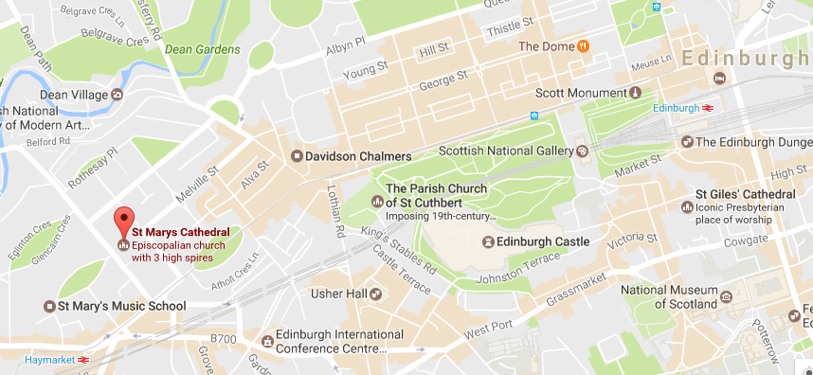

# 

# Travelling to St John's

# St. John's Episcopal Church

# Princes St,

# Edinburgh

# EH2 4BJ, UK

# St John's is at the west end of Princes Street, in the heart of Edinburgh. It is about 10 minutes walk from either Edinburgh Waverley or Haymarket station and many bus routes stop near to the church in Princes Street or Lothian Road.

# For information on reaching St John's by public transport see Lothian Buses or Traveline Scotland

# 

# Travelling to Edinburgh

# Flights to Edinburgh

# Edinburgh Airport lies 8km to the west of Edinburgh and is the third biggest airport in the UK in terms of passenger numbers, following London and Manchester.  Visitors can get to and from the airport by bus, car and taxi.  Subject to the time of day, the average journey time by road can take approximately 25 minutes.

The Airlink 100 operates a frequent bus service (every 10 minutes at peak times) between Edinburgh Airport and the city centre, with designated stops en route. The service starts at 04.30 and runs until 00.22 at night, with the journey taking 20 minutes. Tickets cost £4.50 single and £7.50 return.

The N22 bus also departs from outside the Airport entrance and runs every half an hour through the night until the Airlink service starts again. For more information about these services visit [www.flybybus.com](http://www.flybybus.com)

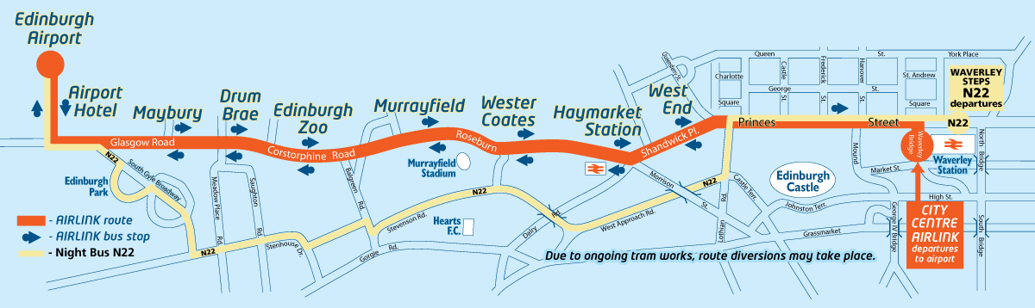

**Trains to Edinburgh**

Edinburgh’s two major railway stations, Waverley and Haymarket, operate regular services to other parts of Scotland and the UK on a frequent basis.

* [**Virgin Trains East Coast**](https://www.virgintrainseastcoast.com/) provide links from Edinburgh to London, Newcastle, York, Leeds and Aberdeen.  Rail travellers can travel to London in approximately five hours.
* [**Virgin Rail**](http://www.virgintrains.co.uk/routes-stations/edinburgh%20waverley/#routesFinder) operates a service on the west coast to London via Lockerbie, Preston, Birmingham and Coventry.
* **Caledonian Sleeper** is a popular overnight service operating between Edinburgh and London (Euston) every night (except Saturday). With a range of accommodation types, guests can wake up in Edinburgh refreshed and ready to start their day. For more information and to book visit <https://www.sleeper.scot>
* **Scotrail** operates a full schedule of trains throughout Scotland. [Visit Scotrail’s website for full details](https://www.scotrail.co.uk/) <https://www.scotrail.co.uk>

**Edinburgh Trams**

Edinburgh Trams run between the Airport and York Place every 8-10 minutes Monday to Saturday and every 12-15 minutes on a Sunday. The closest tram stop to the EICC is at Haymarket Station. Please visit Edinburgh Trams website for more details.

**Other useful links**

[National Rail Enquiries](http://www.nationalrail.co.uk/): <http://www.nationalrail.co.uk>

[Traveline Scotland](http://travelinescotland.com/cms/content/RailLinks.xhtml): <http://www.travelinescotland.com>

**Road Transport**

An extensive road network links Edinburgh to the rest of Scotland and UK making access to the capital easy by car.

Driving times from Edinburgh:

* To Glasgow on M8 – 1 hour
* To Aberdeen on M/A90 – 2 hours 45 minutes
* To Inverness on A9 – 3 hours 30 minutes
* To London on M1 – 8 hours

**Useful tools to plan your journey by road:**   
  
[AA Route Planner](http://www.theaa.com/route-planner/index.jsp) - [www.theaa.com](http://www.theaa.com)   
[RAC Route Planner](http://www.rac.co.uk/route-planner/) - <http://www.rac.co.uk/route-planner/>

You could also travel by coach to Edinburgh from numerous destinations throughout the UK. For further information please contact National Express - [www.nationalexpress.com](http://www.nationalexpress.com)

# Accommodation

Convention Edinburgh has negotiated rates for Mothers’ Union General Meeting 2017 and is pleased to offer a free online accommodation booking service to those attending this event.

To view and book the various accommodation options please click on the link below

[https://goo.gl/npcCYp](https://cabs.conventionedinburgh.com/ei/cm.esp?id=150605&pageid=_4SM0MJUE8)

Credit card details are required to make a booking and confirmation shall be sent to your e-mail address.  Payment should be made directly with the accommodation provider at the time of your stay.

# Other Information

All additional information will be added to the Mothers’ Union website so please do check there for updates. If you have any questions please contact Rachael Arding – [Rachael.arding@mothersunion.org](mailto:Rachael.arding@mothersunion.org), 0207 222 5533.

Invite you to a

A Taste of Scotland and Ceilidh Band

On

Friday 29th September 2017

7.30pm

Join us for a drinks reception, three course dinner, followed by a live Ceilidh band and dancing – a traditional evening of Scottish entertainment in the beautiful surroundings

at

The Roxburghe Hotel

*Please join us for an evening of good company and some sparkling entertainment!*

**TICKETS £50.00 per member, £75.00 per non-member go on sale on 20th February 2017**

Available by filling out booking form.

# The Roxburghe Hotel

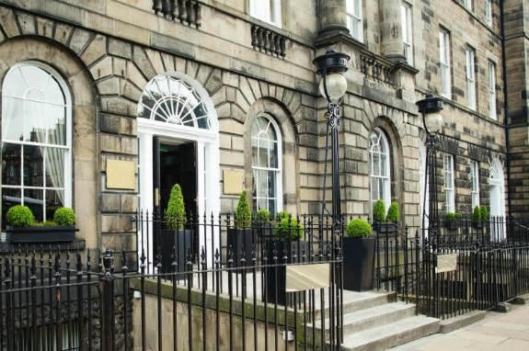

A storied icon building situated on the famous Charlotte Square, The Roxburghe Hotel is very much a destination in itself. The Roxburghe welcomes guests into its historic walls for a stay that combines a traditional British experience with modern hospitality.

We are delighted that this beautiful and luxurious hotel will play host to our evening entertainment where we look forward to welcoming guests and enjoying some wonderful food made with local ingredients, a live Ceilidh band and the opportunity to gather together with friends in wonderful surroundings.

A short walk from both St Mary’s and St Johns, the event will be shortly after the service on Friday therefore the dress code will be smart-casual. We look forward to welcoming you at this special event!



**Taste of Scotland**

**and Ceilidh Band Booking Form**

**BOOKING FORM**

To order tickets:

Return ticket order form to: FAO: Rachael Arding, Mary Sumner House,

**Please send me ............ tickets at £50.00 (member)**

**Please send me ............ tickets at £75.00 (non-member) for the Gala Dinner**

Please note tables are of 10

Name: _______________________________________________

Telephone number:_____________________________________

Address:______________________________________________

Post Code:____________________________________________

Email:________________________________________________

Diocese:________________________________________________

You will be contacted via email nearer the time regarding the menu.

I enclose a cheque made payable to: Mothers’ Union

*Alternatively you may call Mothers’ Union and book tickets over the phone – 020 7222 5533. Please make sure you have your card details to hand to make payment.*

If you have booked for additional people please make sure you include the names of everyone in your booking when returning this form

# Directions from St Mary’s Cathedral to the Roxburghe Hotel

It is really simple to come to the Gala Dinner straight after the Celebration service. It is either a 13-16 minute walk or you can take advantage of the wonderful tram service

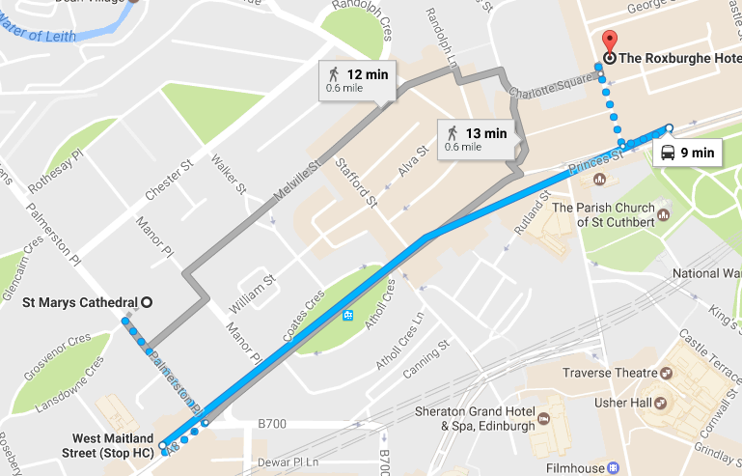

The grey lines show walking routes.

The blue line shows the journey by bus where you will need to take the short 3 minute walk to bus stop HC (West Maitland Street) where you can jump on the following buses: 3 31 33 X31 to stop PB (Princes Street).

Bus information is correct at time of going to press. You can plan your travel by bus in Edinburgh through this website: [www.lothianbuses.co.uk](http://www.lothianbuses.co.uk)